Pregnancy Revision for test 2

Section II: Order of events in fetal Development: Place a number on the line in the order you think the events occur

11. _______ Cells begin to divide
12. _______ Fertilized egg implants into
uterus wall
13._______ Cervix dilates
14. ______ Pregnancy is full term baby turns head down
15._______ Gender can be seen
16._______ Fetus can hear
17._______ Sperm cell enters egg
18_______ All organs can function
19_______ Heart begins to beat
20._______ Hands and feet develop

Section III: Order of Development: Place these baby names in the order in which they occur during pregnancy by writing the number under each name. 1 being the first to occur and 5 being the last to occur.

A. Baby B. Blastocyst C. Zygote D. Embryo E. Fetus
22. _______ 23. _______ 24._______ 25._______ 26._______

Section IV: Terms during pregnancy: Place the Terms with the correct definition for pregnancy.

Amniotic Sac
Placenta

Umbilical Chord
Vernix
Crowning Lanugo
27. __________________Supplies fetus with oxygen, supplies fetus with nutrients, and passes out wastes from the fetus.

28. ________________ Is a rope like structure that connects the embryo to the placenta. It has 1 large vein, and 2 arteries.

29. _________________ Acts as temperature control, protection from shock, barrier to infection.

30. _________________ Is fine downy hair that covers the fetus to help insulate, and regulate body temperature.

31. _________________ Is white, cheese-like substance that acts like a waterproof barrier against the amniotic fluid.

32. _________________ Is the appearance of the baby’s head during delivery.

Section V: Order Signs of Labor and Stages of Birth: Place the stages of birth in the order in which they occur during pregnancy. 1 is the first to occur and 6 the last to occur.
Birth of Baby Head appears Birth of placenta 33. _______ 34._______ 35._______
Water Breaks Contractions Dilation of cervix
36. _______ 37._______ 38._______
Section VI: Match the correct type of pregnancy to the definition:
A. Medication given or water sac broken by plastic hook (amnio-hook)

B. A shot administered in the woman’s lower back to aid in pain relief.

C. A form of childbirth in which a surgical incision is made through a mother's abdomen and uterus to deliver one or more babies.

D. When baby delivered either foot first or buttocks first.

E. Delivery of a baby without using drugs or surgery during birth.

F. An incision between the vagina and anus (perineum) help with crowning of the baby, to prevent muscles from tearing

G. Assist mother if she becomes too tired, cup on baby’s head with slight suction

H. Guide baby’s head out of birth canal

39. Natural Birth _______

40. Induced Labor _______

41. Breech Birth _______

42. Cesarean Section _______

43. Epidural_______

44. Episiotomy_______

45. Vacuum Extraction _______

46. Forceps_______

Section VIII: Place the pictures in order from day one to delivery. Include trimester next to picture
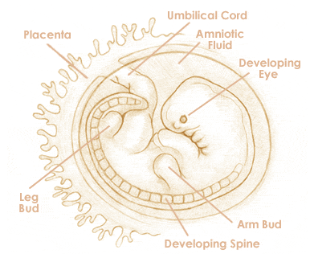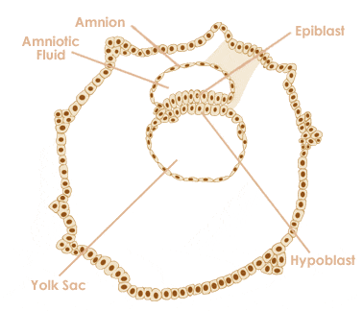

55. ___________________________________________ 56.___________________________________________

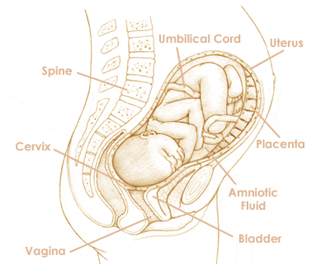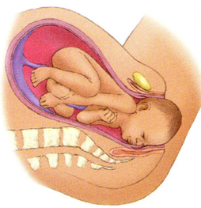

57. ___________________________________________ 58.___________________________________________

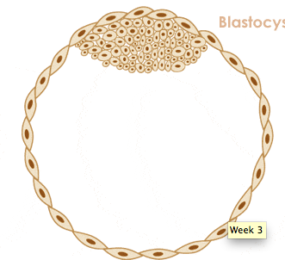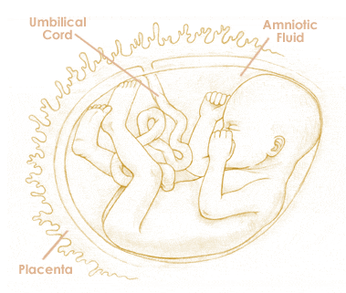

59. ___________________________________________ 60.____________________________________________

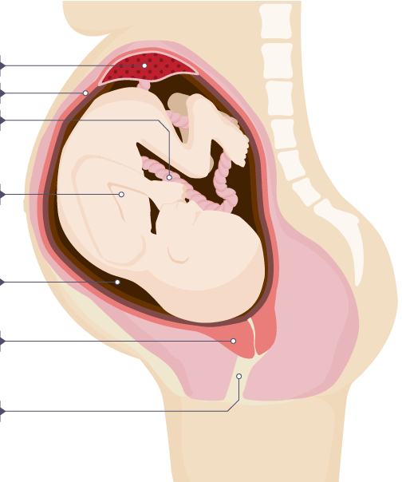
Label the following:

What is the difference between ultrasound and x-ray?

Why do we use ultrasound rather than x-ray to monitor the fetus’ growth?

Hormone | Function
Oxytocin
Progesterone
Prolactin
Human Chorionic Gonadotrophin
Estrogen
What do the following hormones do during pregnancy?

When do the following milestones occur?

- Smiling
- Laughing
- Crawling
- Sitting up
- Start teething

Describe 2 different reflexes that newborns have

